**Assignment #1**

**Stats 147 Fall 2017 Sec. 2**

Sarah Ruckman

SID: 7194

1. Using R, complete the following.
   1. Read in and print out the .csv file, wheat1.csv

R Code:

> #Statistics 147 Assignment #1

> #Section 002

> #Fall 2017

> #Sarah Ruckman

> #R Question 1 part i

> #read in csv file wheat1.csv

> wheat = read.csv("C:\\Users\\sarah\\Downloads\\wheat1.csv", header = TRUE)

> #Print for check

> wheat

HardRed SoftRed

1 29.8 49.0

2 29.5 53.4

3 38.2 54.2

4 39.9 59.0

5 36.0 56.6

6 39.0 57.9

7 36.7 55.8

8 31.1 43.2

9 26.9 55.6

10 36.6 54.2

11 37.8 59.9

12 35.4 63.2

13 37.2 50.0

14 39.9 60.9

15 38.1 56.1

16 28.5 54.3

17 36.9 62.1

* 1. Find the sum of the yields/acre for the seventeen acres of SoftRed wheat. Call this variable sum_SoftRed.

R Code:

> #R Question 1 part ii

> #Find the sum of the yields for SoftWheat

> #call this variable sum_SoftWheat

> #Use names function to see names

> names(wheat)

[1] "HardRed" "SoftRed"

> #Use attach function to separate columns of data

> attach(wheat)

> #Print as check

> HardRed

[1] 29.8 29.5 38.2 39.9 36.0 39.0 36.7 31.1 26.9 36.6 37.8 35.4 37.2 39.9 38.1

[16] 28.5 36.9

> SoftRed

[1] 49.0 53.4 54.2 59.0 56.6 57.9 55.8 43.2 55.6 54.2 59.9 63.2 50.0 60.9 56.1

[16] 54.3 62.1

> #Find the sum of SoftRed

> sum_SoftRed = sum(SoftRed)

> #Print as check

> sum_SoftRed

[1] 945.4

**The total is 945.4 yields/acre**

* 1. Find the sum of the yield/acres for the seventeen acres of HardRed wheat. Call this variable sum_HardRed

R Code:

> #R question 1 part iii

> #Find the sum of the yields for HardRed Wheat

> #call this variable sum_HardRed

> sum_HardRed = sum(HardRed)

> #Print as check

> sum_HardRed

[1] 597.5

**The total is 597.5 yield/acre**

* 1. Find the sum of the yield/acre for the thirty-four acres of wheat. Call this variable total_all.

R Code:

> #R question 1 part iv

> #Find the total sum

> #call this variable total_all

> total_all = sum_HardRed + sum_SoftRed

> #Print as check

> total_all

[1] 1542.9

**The total is 1542.9 yield/acre**

1. Write a SAS program to complete the following.
   1. Read in and print out the data.

SAS Code:

options ls = **70** ps = **55** nocenter formdlim = '*';

/* ls = linesize, ps = pagesize, nocenter = justifies output, formdlim = overrides the internal page breaks

and replaces them with the designated symbol */

/* Create titles */

title1 'Statstics 147 Assignment #1';

title2 'Section 002';

title3 'Fall 2017';

title4 'Sarah Ruckman';

title5 'SAS Question 1 Part i';

/* Read file */

/* Create temporary data set called wheat */

**data** wheat;

infile 'C:\Users\sarah\Downloads\wheat2.dat' firstobs = **2**;

input HardRed SoftRed;

/* Print the data as a check */

**proc** **print**;

**run**;

**quit**;

**Output:**



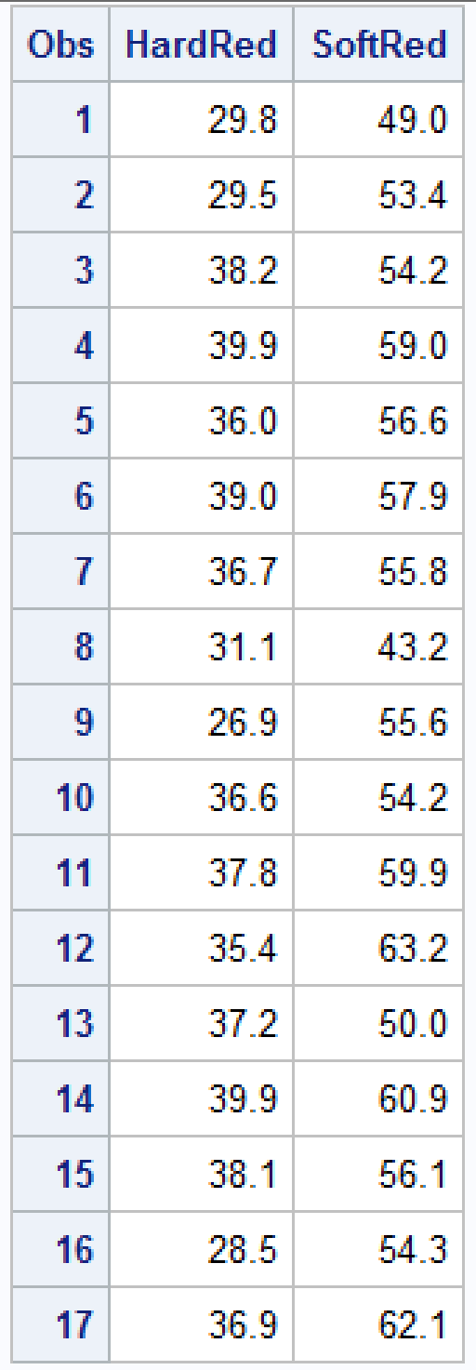

* 1. Sort the data by variable HardRed

SAS Code:

options ls = **70** ps = **55** nocenter formdlim = '*';

/* ls = linesize, ps = pagesize, nocenter = justifies output, formdlim = overrides the internal page breaks

and replaces them with the designated symbol */

/* Create titles */

title1 'Statstics 147 Assignment #1';

title2 'Section 002';

title3 'Fall 2017';

title4 'Sarah Ruckman';

title5 'SAS Question 1 Part ii';

/* Read file */

/* Create temporary data set called wheat */

**data** wheat;

infile 'C:\Users\sarah\Downloads\wheat2.dat' firstobs = **2**;

input HardRed SoftRed;

/* Print the data as a check */

**proc** **print**;

/* Sort by the variable HardRed */

**proc** **sort**;

by HardRed;

/* Print the data*/

**proc** **print**;

**run**;

**quit**;

**Output:**



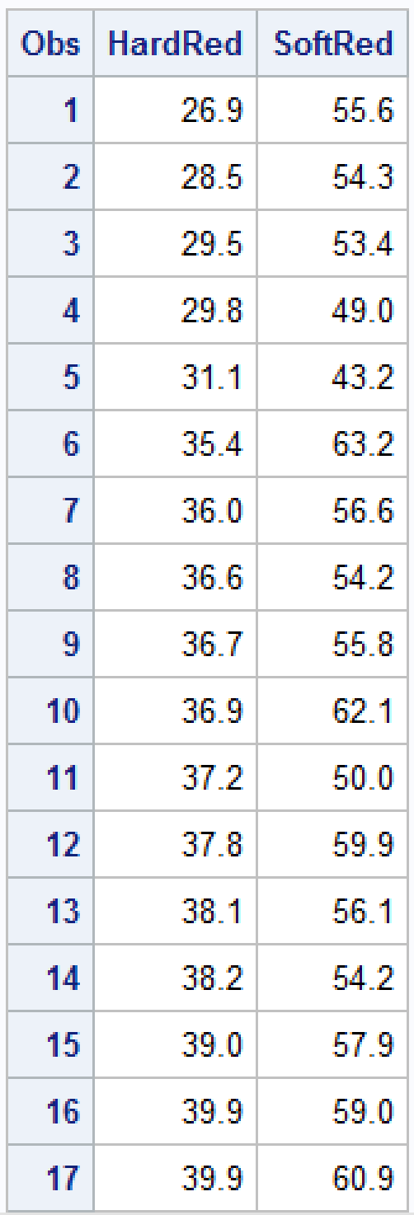

* + 1. What is the largest yield/acre for HardRed wheat?

**The largest yield/acre for HardRed wheat is 39.9 yield/acre.**

* + 1. What is the smallest yield/acre for HardRed wheat?

**The smallest yield/acre for HardRed wheat is 26.9 yield/acre.**